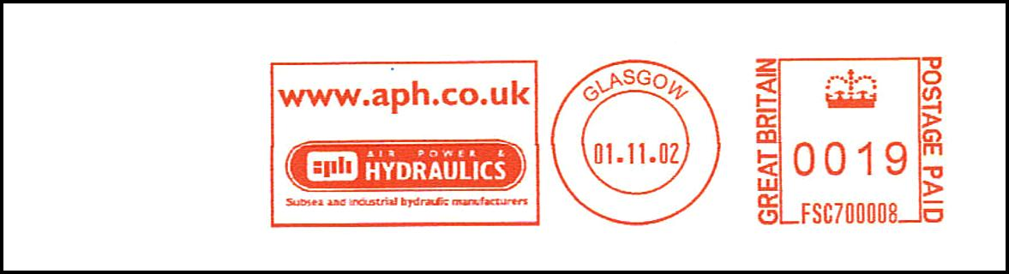
Frama - ‘Mailspirit’: FSC700001 to 700999

This is the start of the FSC700 series, first introduced in May 2001.

The FSC7 series is uncommon and scans of other examples would be appreciated.
FSC700008
GLASGOW
E01.11.02
User: aph Hydraulics
Thematics: None
Notes: None

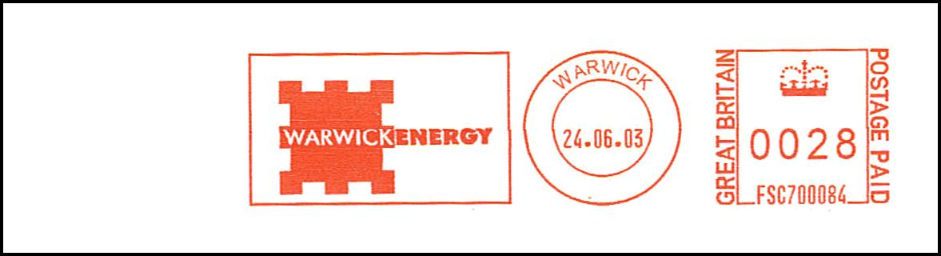
FSC700084
WARWICK
E24.06.03
User: Warwick Energy Ltd.
Thematics: None
Notes: None
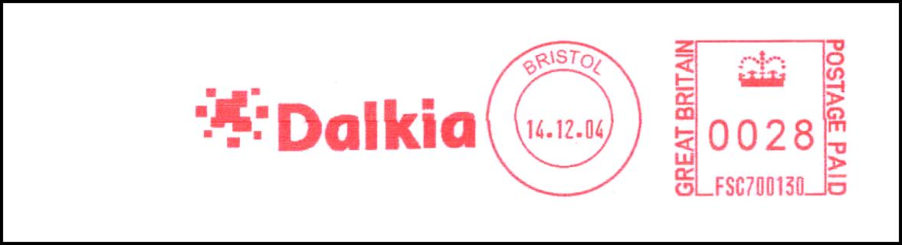
FSC700130
BRISTOL
E14.12.04, L30.05.07
User: Dalkia ETS Ltd.
Thematics: None
Notes: None

FSC700130
BRISTOL
E30.05.07
User: Dalkia ETS Ltd.
Thematics: None
Notes: None
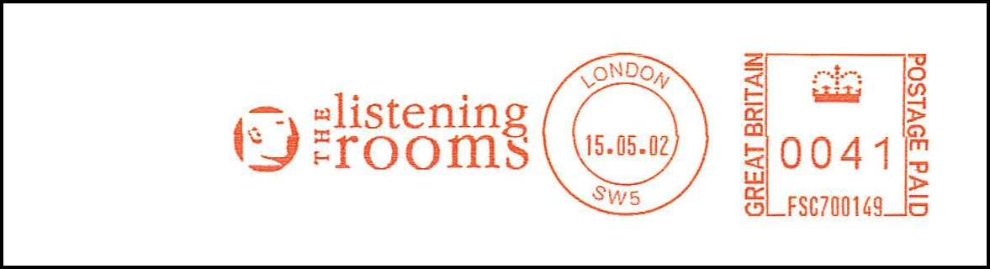
FSC700149
LONDON SW5
E15.05.02
User: The Listening Rooms
Thematics: Human Faces
Notes: None

FSC700161
VIRGINIA WATER
E26.10.01
User: Wentworth Travel
Thematics: None
Notes: None

FSC700162
CRAWLEY
E03.08.01
User: World Fuel Services Ltd.
Thematics: World Globes, Aircraft
Notes: None

FSC700264
READING
E18.05.02
User: PJ Drew Ltd.
Thematics: None
Notes: None
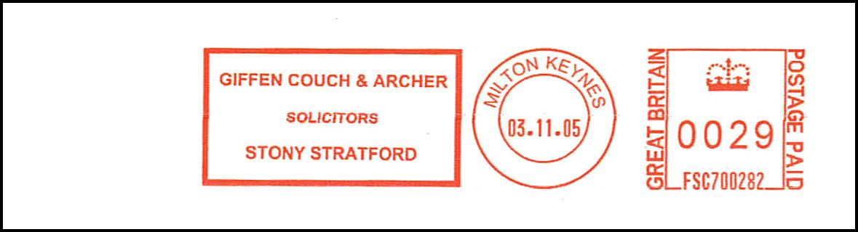
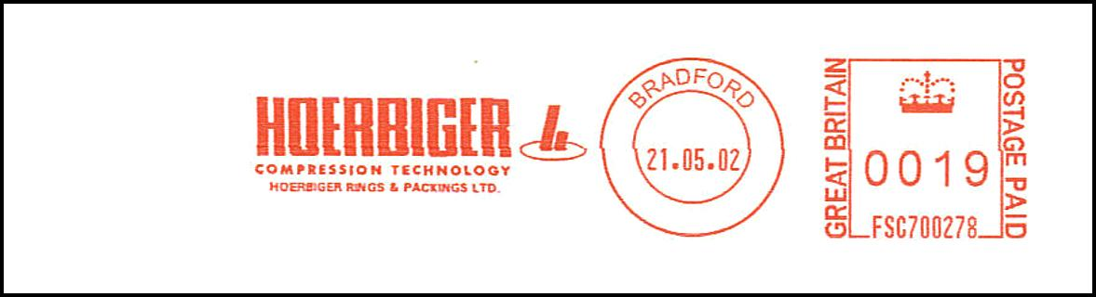
FSC700278
BRADFORD
E21.05.02
User: Hoerbiger Compression Technology
Thematics: None
Notes: None
FSC700282
MILTON KEYNES
E03.11.05
User: Giffen Couch & Archer Solicitors
Thematics: None
Notes: None
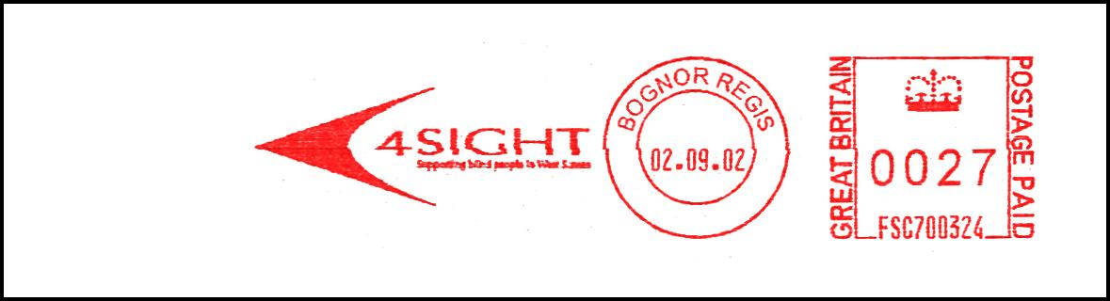
FSC700324
BOGNOR REGIS
E02.09.02
User: 4 Sight
Thematics: None
Notes: None
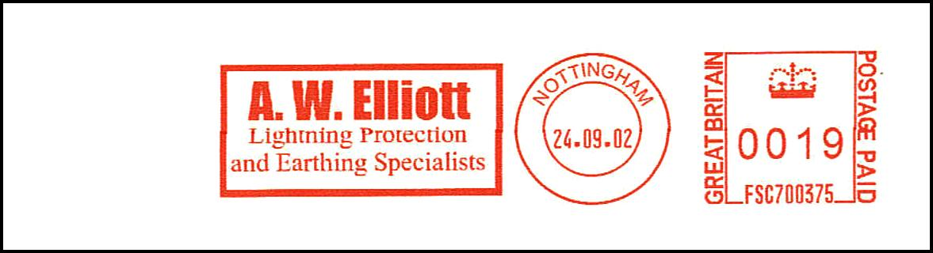
FSC700375
NOTTINGHAM
E24.09.02
User: A. W. Elliott Lighting
Thematics: None
Notes: None
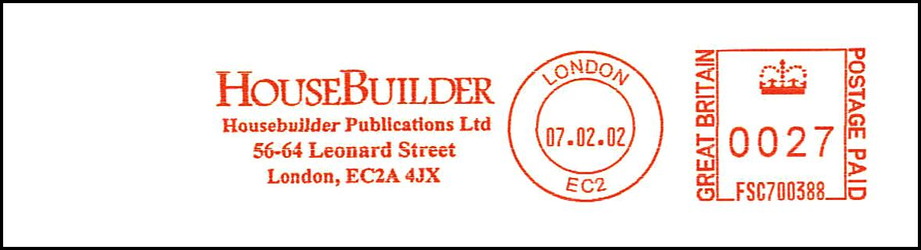
FSC700388
LONDON EC2
E07.02.02
User: HoueBuilder Publications Ltd.
Thematics: None
Notes: None

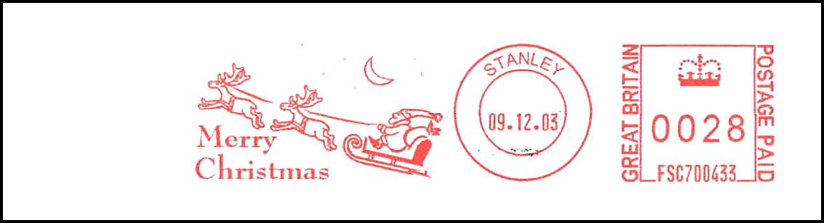
FSC700395
MANCHESTER
E30.09.05
User: Mines Advisory Group (MAG)
Thematics: Warfare
Notes: None
FSC700433
STANLEY
E09.12.03
User: Union Snack Ltd.
Thematics: Christmas
Notes: None

FSC700433
STANLEY
E29.04.04
User: Union Snack Ltd.
Thematics: None
Notes: None
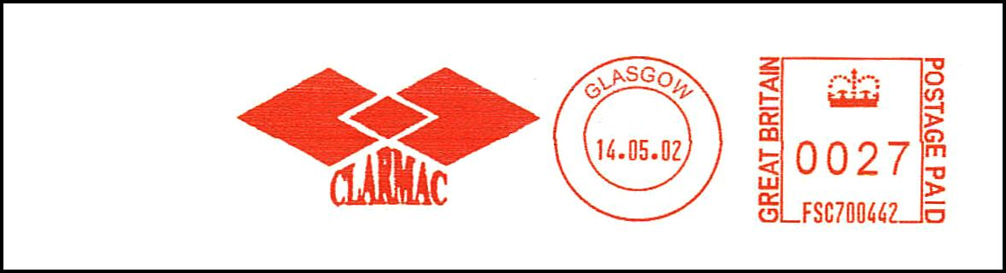
FSC700442
GLASGOW
E14.05.02
User: Clarmac
Thematics: None
Notes: None
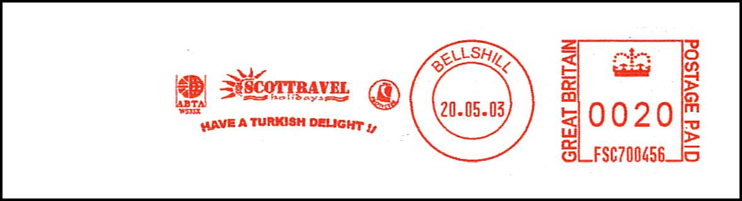
FSC700456
BELLSHILL
E20.05.03
User: Scottravel
Thematics: Food
Notes: None

FSC700469
EDINBURGH
E08.07.03
User: Unknown
Thematics: None
Notes: None
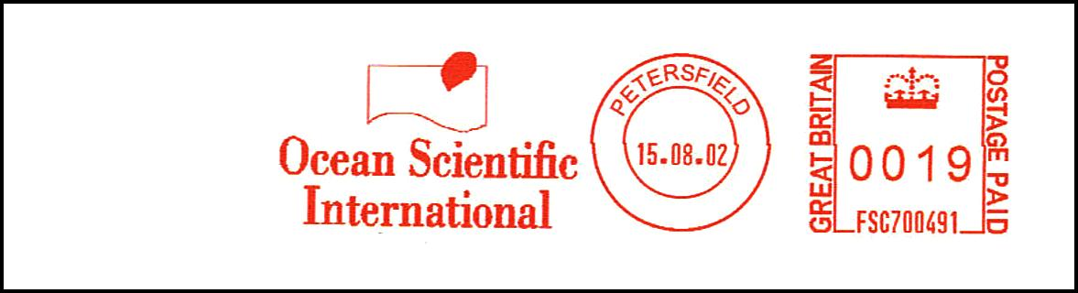
FSC700491
PETERSFIELD
E15.08.02
User: Ocean Scientific International
Thematics: None
Notes: None

FSC700491
PETERSFIELD
E14.07.05
User: Ocean Scientific International Ltd.
Thematics: None
Notes: None
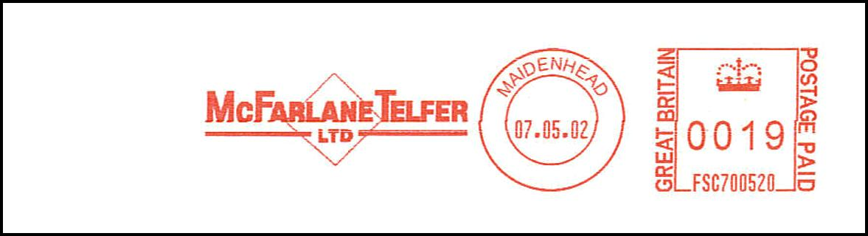
FSC700520
MAIDENHEAD
E07.05.02
User: McFarlane Telfer Ltd.
Thematics: None
Notes: None

FSC700528
WELLINGBOROUGH
E21.05.02
User: Jaybeam
Thematics: None
Notes: None

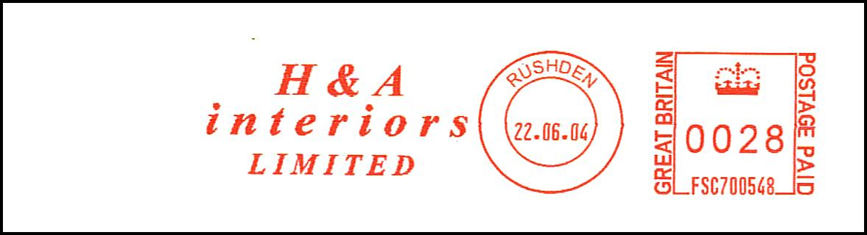
FSC700529
WOLVERHAMPTON
E12.08.04
User: Laystall
Thematics: None
Notes: None
FSC700548
RUSHDEN
E22.06.04
User: H & A Interiors Ltd.
Thematics: None
Notes: None


FSC700574
RAYLEIGH
E05.11.02
User: Care Tech UK Ltd.
Thematics: Disabled
Notes: None
FSC700591
NORTHAMPTON
E16.01.03
User: Forces & Corporate Publishing Ltd.
Thematics: None
Notes: None

FSC700593
AYLESFORD
E17.10.05
User: Unknown
Thematics: None
Notes: None

FSC700594
ROCHESTER
E03.07.06
User: Rhema
Thematics: None
Notes: None

FSC700597
CANTERBURY
E12.11.02
User: Pioden
Thematics: None
Notes: None

FSC700599
CRAWLEY
E29.07.02
User: World Fuel Services Ltd.
Thematics: World Globe, Aircraft
Notes: None

FSC700609
OMAGH
E31.10.03
User: Unknown
Thematics: None
Notes: None

FSC700632
BIRMINGHAM
E24.09.04
User: Kentex Corporatewear Plc.
Thematics: None
Notes: None
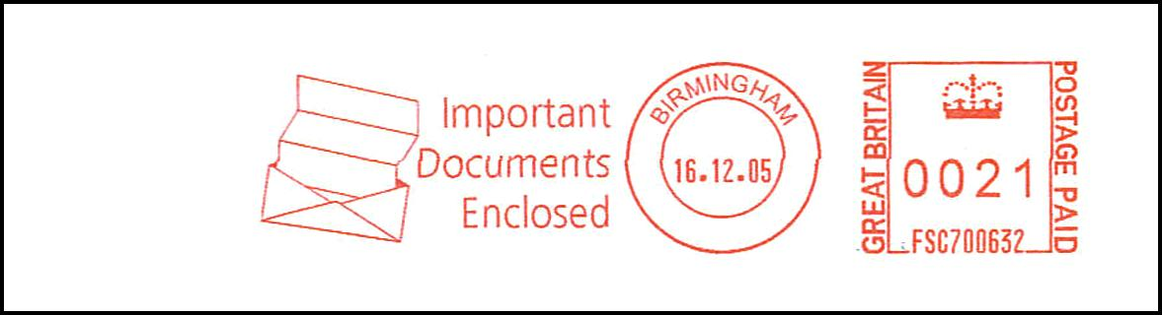
FSC700632
BIRMINGHAM
E16.12.05
User: Kentex Corporatewear Plc.
Thematics: None
Notes: ‘Important Documents Enclosed’ built-in message
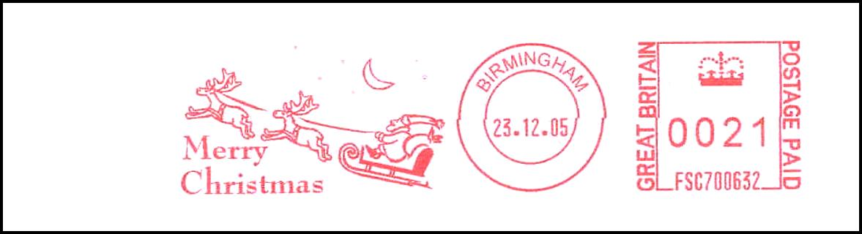
FSC700632
BIRMINGHAM
E23.12.05
User: Kentex Corporatewear Plc.
Thematics: Christmas
Notes: None
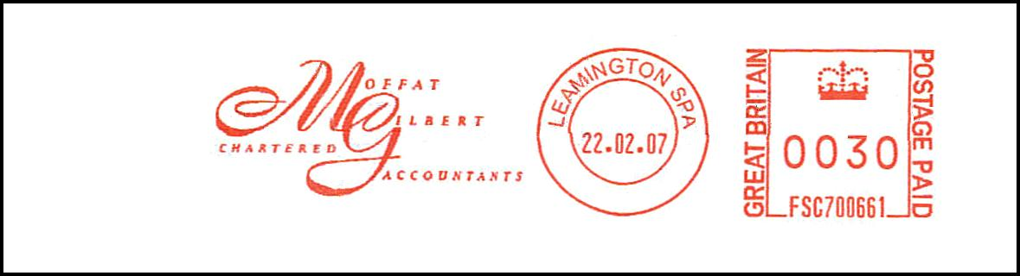
FSC700661
LEAMINGTON SPA
E22.02.07
User: Moffat Gilbert Chartered Accountants
Thematics: None
Notes: None


FSC700700
LONDON EC4
E18.04.07
User: Unknown
Thematics: Heraldry
Notes: None
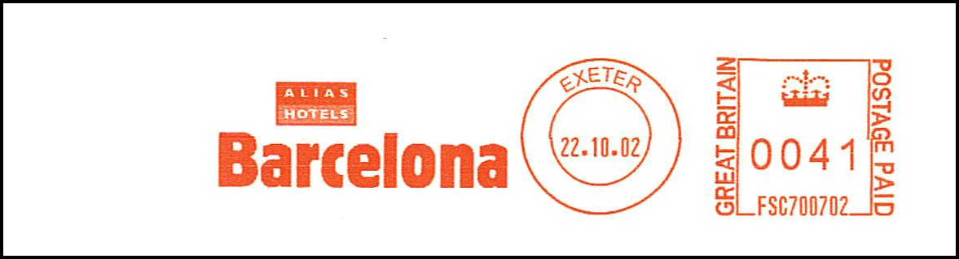
FSC700702
EXETER
E22.10.02
User: Alias Hotels
Thematics: Tourism
Notes: None
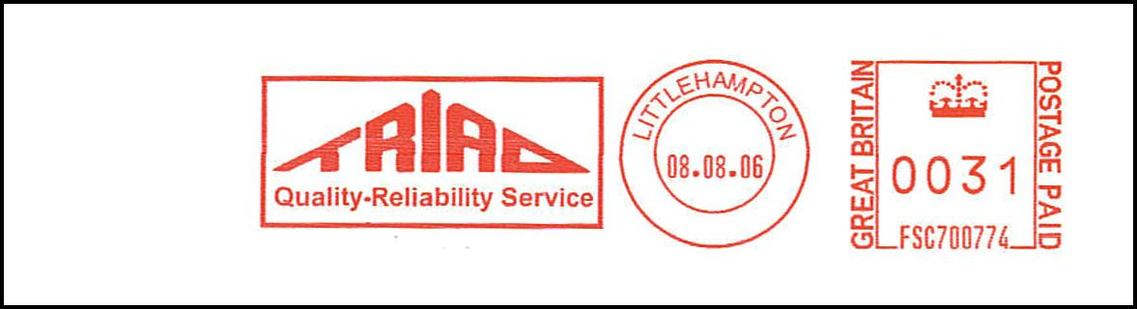
FSC700774
LITTLEHAMPTON
E08.08.06
User: Triad Quality-Reliability Service
Thematics: None
Notes: None

FSC700808
COATBRIDGE
E07.11.05
User: D & G Precision Engineering Ltd.
Thematics: None
Notes: None
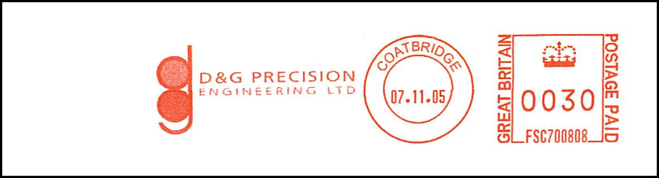
FSC700808
COATBRIDGE
E07.11.05
User: D & G Precision Engineering Ltd.
Thematics: None
Notes: None
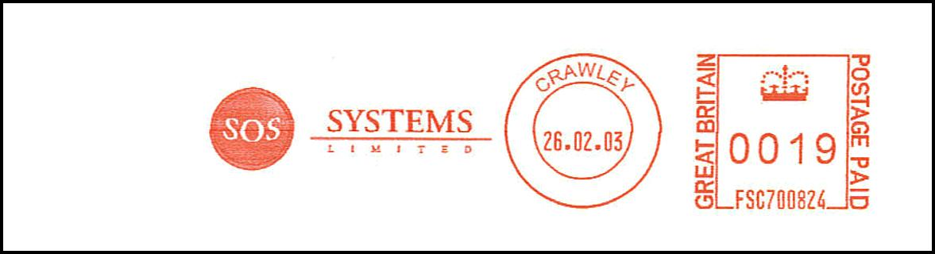
FSC700824
CRAWLEY
E26.02.03
User: SOS Systems Ltd.
Thematics: None
Notes: None

FSC700826
GODALMING
E16.01.04
User: Unknown
Thematics: None
Notes: None
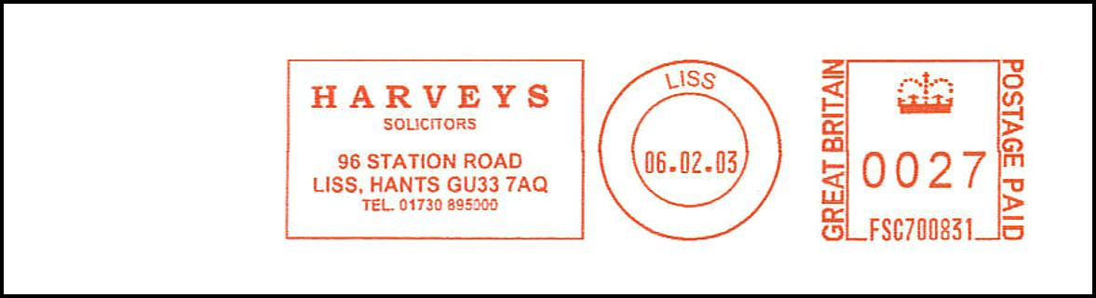
FSC700831
LISS
E06.02.03
User: Harveys Solicitors
Thematics: None
Notes: None
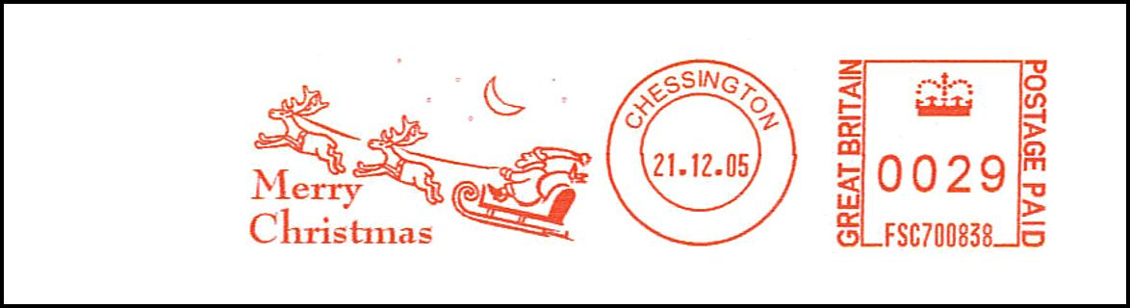
FSC700838
CHESSINGTON
E21.12.05
User: ESG
Thematics: Christmas
Notes: None

FSC700838
CHESSINGTON
E09.08.06
User: ESG
Thematics: None
Notes: None



FSC700850
BRADFORD
E08.01.04
User: Unknown
Thematics: None
Notes: None
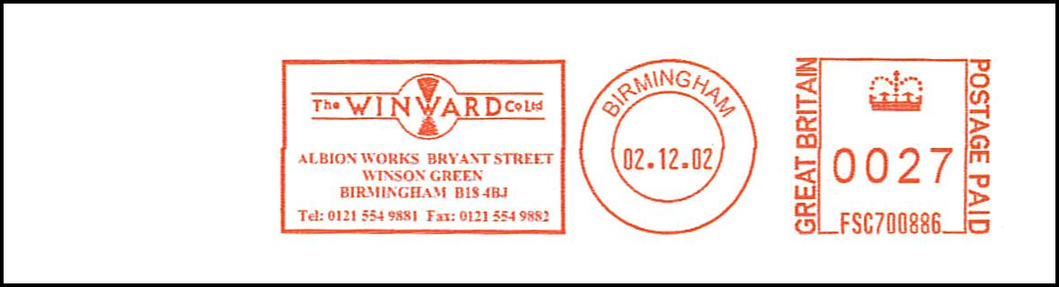
FSC700886
BIRMINGHAM
E02.12.02
User: The Winward Co. Ltd.
Thematics: None
Notes: None
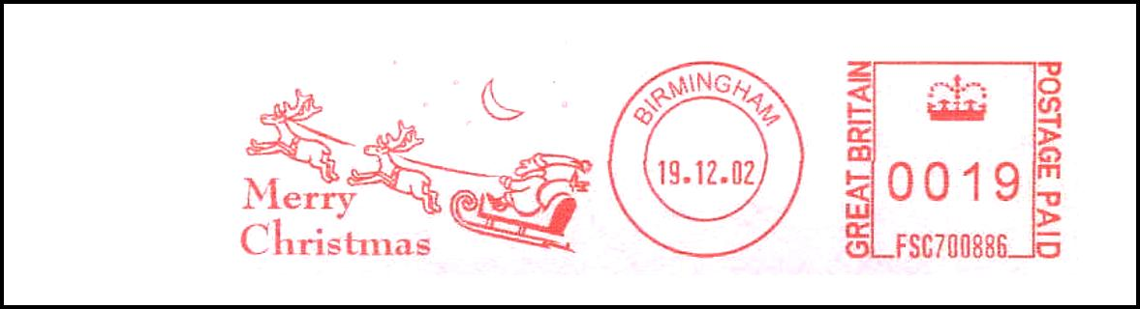
FSC700886
BIRMINGHAM
E19.12.02
User: The Winward Co. Ltd.
Thematics: Christmas
Notes: None

FSC700886
BIRMINGHAM
E07.01.03
User: Cameo
Thematics: None
Notes: None
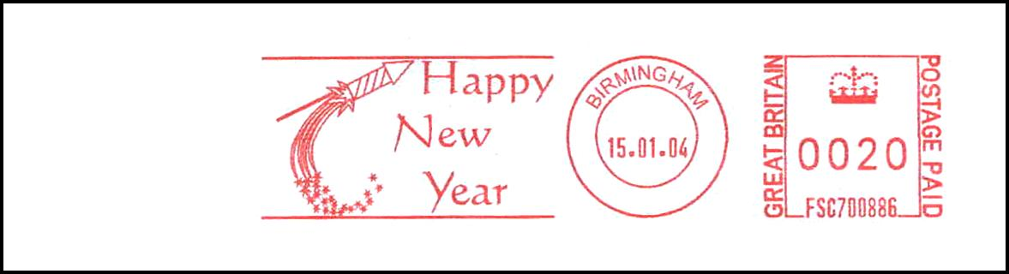
FSC700886
BIRMINGHAM
E15.01.04
User: Camco
Thematics: New Year Celebrations
Notes: None
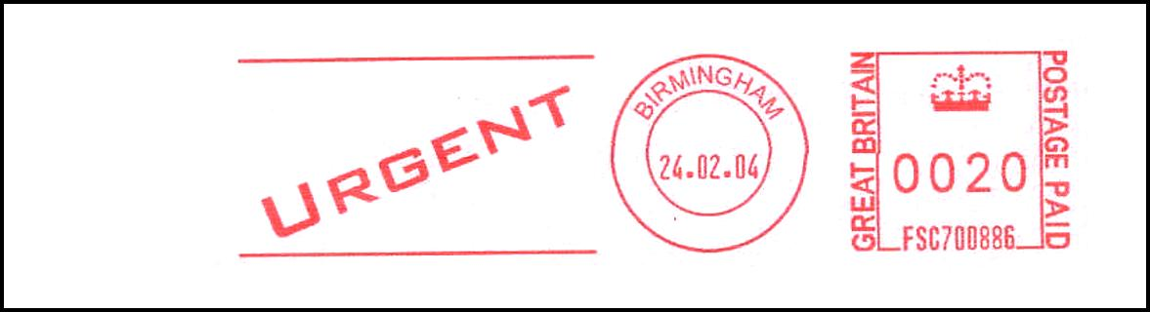
FSC700886
BIRMINGHAM
E15.01.04
User: Camco
Thematics: None
Notes: Is this a pre-loaded message?
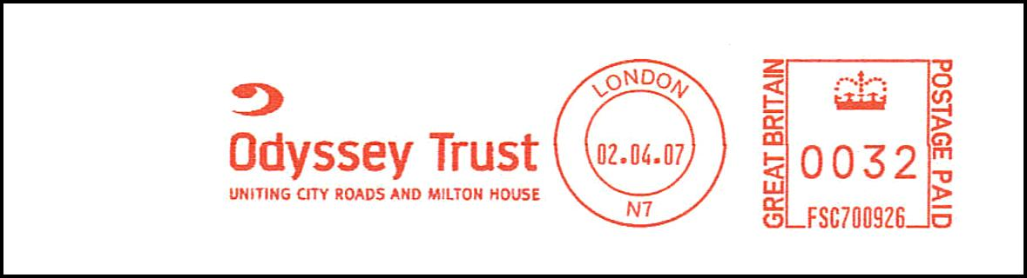
FSC700926
LONDON N7
E02.04.07
User: Odyssey Trust
Thematics: None
Notes: None

